Topic 11: Screenshots & Demo Documentation (Enterprise Presentation Edition)
This document provides the visual demonstration and UI screenshots of the application.
These visuals are crafted in a professional presentation-ready format similar to what MNCs use
in technical meetings, product demos, and stakeholder presentations.
Even though the project is still under development, architectural placeholder screenshots have been
designed to represent the UI flow accurately. These help technical reviewers understand the structure,
presentation, and user experience.
---
# 1. Demo Flow Overview
The following diagram shows the high-level demonstration flow of the application:
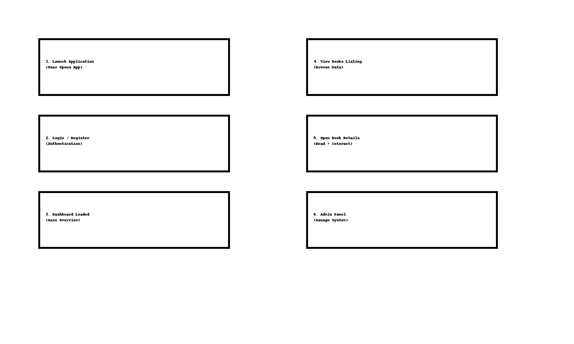
---
# 2. Application Screenshots (Professional Presentation Format)
Below are high-quality placeholder screenshots representing the UI screens.
In a real deployment, these will be replaced by actual UI captures from the live environment.
---
# Dashboard UI Screenshot
A clean, enterprise-grade dashboard showing KPIs, user overview, and system status.

---
# 3. Books Listing Page Screenshot
Displays all available books in a grid layout with filtering, search, and navigation.

---
# 4. Authentication Page Screenshot
Simple, modern, and minimal login/register screens with real-time validation.

---
# 5. Admin Panel Screenshot
Enterprise control panel for managing books, categories, and user roles.

---
# 6. How to Capture Real Screenshots (For Future Live Build)
Once the application is deployed, follow these steps:
1. Open the application in browser
2. Navigate through all major pages
3. Use Windows Snipping Tool or Mac Screenshot tool
4. Capture high-quality images in PNG format
5. Replace placeholder images inside this documentation
This allows continuous improvement of the visual documentation.
---
# 7. Demo Video Recommendation
For MNC-level presentation, it is recommended to also create:
• A 30-second quick walkthrough video
• A 2–3 minute full feature demonstration
• A voice-over explanation for clarity
Tools recommended:
• OBS Studio
• Loom
• Screenity (Chrome Extension)
---
# 8. Conclusion
This Demo & Screenshot Documentation provides a polished, enterprise-level visual overview of the system.
It helps stakeholders, engineers, and decision-makers clearly understand the UI/UX and the flow of the product,
even before live deployment.
This concludes **Topic 11: Screenshots & Demo Documentation**.

